Q1.What do you understand about trends in CC?

Cloud Computing is internet-based service where services are provided by service providers the resources which are provided by service providers are based on request from the users. This services include software, hardware, infrastructure, storage, etc.

In cloud computing most of the times services are freely available for particular services, but for extra usage of functionalities the user needs to pay for such services, so cloud computing is called as pay-as-you-use model.

NIST(National Institute of Standards and Technology) defines cloud computing as a a model for enabling ubiquitous, convenient, on-demand network access to a shared pool of configurable computing resources (e.g., networks, servers, storage, applications, and services) that can be rapidly provisioned and released with minimal management effort or service provider interaction.

Trends in Cloud Computing includes:

1. Hybrid and Multi-cloud Adoption

2. Serverless Computing

3. Edge Computing

4. AI and Machine Learning Integration

5. Cloud-native Technologies

6. Sustainability and Green Cloud Initiatives

7. Cloud Security

8. Automation and DevOps Integration

9. Quantum Computing in the Cloud

10. Cloud-based Blockchain

1. Hybrid and Multi-Cloud Strategies: Companies are increasingly using a combination of private and public clouds to optimize performance and cost-efficiency.
2. Serverless Computing: Users can build and run applications without managing infrastructure, with services like AWS Lambda.
3. Edge Computing: Processing data closer to its source (on edge devices) to reduce latency and bandwidth use.
4. Artificial Intelligence (AI) and Machine Learning (ML) Integration: Cloud platforms provide scalable AI/ML services.
5. Cloud-Native Applications: Microservices and containerized apps designed for cloud environments.

Q2.Pros and Cons of CC

Cloud Computing is internet-based service where services are provided by service providers the resources which are provided by service providers are based on request from the users. This services include software, hardware, infrastructure, storage, etc.

Advantages of cloud computing

1. **Cost:** It reduces the huge capital costs of buying hardware and software.
2. **Speed:** Resources can be accessed in minutes, typically within a few clicks.
3. **Scalability:**We can increase or decrease the requirement of resources according to the business requirements.
4. **Productivity:**While using cloud computing, we put less operational effort. We do not need to apply patching, as well as no need to maintain hardware and software. So, in this way, the IT team can be more productive and focus on achieving business goals.
5. **Reliability:**Backup and recovery of data are less expensive and very fast for business continuity.
6. **Security:**Many cloud vendors offer a broad set of policies, technologies, and controls that strengthen our data security.

Disadvantages of cloud computing

1. **Downtime**: Internet dependency can lead to unplanned downtimes.
2. **Security** Concerns: Sensitive data could be vulnerable to breaches.
3. **Limited** Control: Users have less control over the cloud infrastructure.
4. **Latency**: Data transmission over the internet can introduce delays.

Q3.Explain VM and VMware

**Virtual machines: virtual computers within computers**

A virtual machine, commonly shortened to just VM, is no different than any other physical computer like a laptop, smart phone, or server. It has a CPU, memory, disks to store your files, and can connect to the internet if needed. While the parts that make up your computer (called hardware) are physical and tangible, VMs are often thought of as virtual computers or software-defined computers within physical servers, existing only as code.

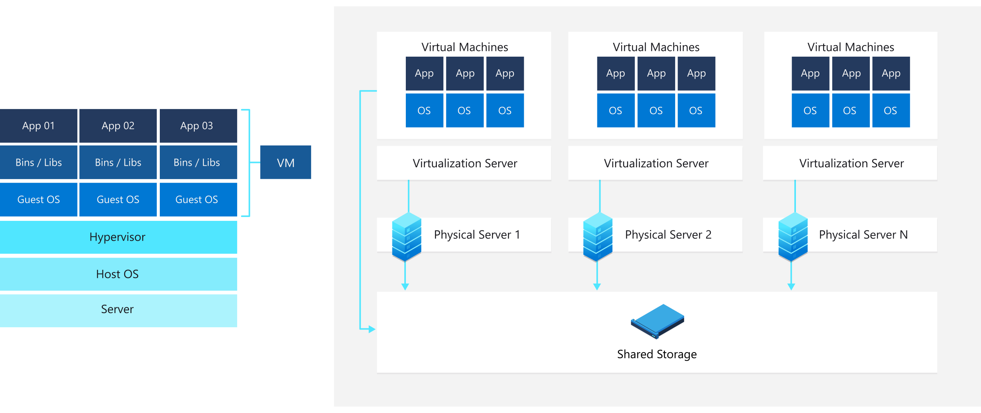

**How does a virtual machine work?**

Virtualization is the process of creating a software-based, or "virtual" version of a computer, with dedicated amounts of CPU, memory, and storage that are "borrowed" from a physical host computer—such as your personal computer— and/or a remote server—such as a server in a cloud provider's datacentre. **A virtual machine is a computer file, typically called an image, that behaves like an actual computer.**

**VMware**: VMware is a company that provides virtualization software and services. Its popular products like VMware Workstation and vSphere help users create, manage, and run multiple VMs on a single physical machine, increasing resource efficiency.

**open-source virtualization technologies to know in 2020**

This table summarizes each Virt Tool, including license information and links to each tool's website and source code. Much of this information comes from the Virt Tools website and each tool's site.

| **Name** | **What It Is** | **License** | **Source Code** |
| --- | --- | --- | --- |
| [Kernel-based Virtual Machine (KVM)](https://www.linux-kvm.org/page/Main_Page) | A virtualization module in the Linux kernel that allows the kernel to function as a hypervisor | GNU GPL or LGPL | [Source code](https://git.kernel.org/pub/scm/virt/kvm/kvm.git) |
| [Quick Emulator (QEMU)](https://www.qemu.org/) | A generic and open source machine emulator and virtualizer | GPLv2 | [Source code](https://git.qemu.org/git/qemu.git) |
| [Libvirt](https://libvirt.org/) | A library and daemon providing a stable, open source API for managing virtualization hosts | GNU | [Source code](https://libvirt.org/git/?p=libvirt.git) |
| [Libguestfs](http://libguestfs.org/) | A set of tools for accessing and modifying VM disk images | LGPL, GPL | [Source code](https://github.com/libguestfs/libguestfs) |
| [Virt-manager](https://virt-manager.org/) | A desktop user interface for managing VMs through libvirt | GPLv2+ | [Source code](https://github.com/virt-manager/virt-manager) |
| [Libosinfo](https://libosinfo.org/download/) | Provides a database of information about operating system releases to assist in optimally configuring hardware when deploying VMs | LGPLv2+ | [Source code](https://gitlab.com/libosinfo/libosinfo) |

Q4.Discuss Soap and Rest in detail

**SOAP** stands for Simple Object Access Protocol.

SOAP is a protocol which was designed before REST and came into the picture. The main idea behind designing SOAP was to ensure that programs built on different platforms and programming languages could exchange data in an easy manner.

**When to use SOAP?**

SOAP should be used in the following instances

1. **Asynchronous processing and subsequent invocation** – if there is a requirement that the client needs a guaranteed level of reliability and security then the new SOAP standard of SOAP 1.2 provides a lot of additional features, especially when it comes to security.
2. **A Formal means of communication** – if both the client and server have an agreement on the exchange format then SOAP 1.2 gives the rigid specifications for this type of interaction.
3. **Stateful operations –**ifthe application has a requirement that state needs to be maintained from one request to another, then the SOAP 1.2 standard provides the structure to support such requirements.

**REST** stands for Representational State Transfer.

REST was designed specifically for working with components such as media components, files, or even objects on a particular hardware device. Any web service that is defined on the principles of REST can be called a Restful web service. A Restful service would use the normal HTTP verbs of GET, POST, PUT and DELETE for working with the required components.

**When to use REST?**

1. **Limited resources and bandwidth** – Since SOAP messages are heavier in content and consume a far greater bandwidth, REST should be used in instances where network bandwidth is a constraint.
2. **Statelessness** – If there is no need to maintain a state of information from one request to another then REST should be used. If you need a proper information flow wherein some information from one request needs to flow into another then SOAP is more suited for that purpose.
3. **Caching**– If there is a need to cache a lot of requests then REST is the perfect solution. At times, clients could request for the same resource multiple times. This can increase the number of requests which are sent to the server.
4. **Ease of coding**– Coding REST Services and subsequent implementation is far easier than SOAP. So if a quick win solution is required for web services, then REST is the way to go.

Q5.Describe edge computing in detail

An edge computing environment distributes and manages workloads beyond the data centre or cloud, in or near the locations where an enterprise conducts business

Edge computing is about placing computer workloads (both hardware and software) as close as possible to the edge—to where the data is being created and where actions are occurring. Edge computing environments give customers faster response times, greater data privacy, and reduced data transfer costs.

What is Edge Compute?

Edge compute is the data processing that takes place at the network edge to decrease latency and reduce demands on cloud compute and data centre resources. Edge computing takes place in intelligent devices — right at the location where sensors and other instruments are gathering and processing data — to expedite that processing before devices connect to the Internet of Things (IoT) and send the data on for further use by enterprise applications and personnel.

For telecommunications providers, edge computing environments allow customers to run workloads in their multi-access edge computing (MEC) facilities that are embedded in local communities.

For farmers, edge computing means monitoring growing conditions on a much finer scale to more precisely act and increase yields.

For retailers, edge computing means they can manage the lifecycles of their broad-ranging workloads on devices of many types and architectures across multiple store locations.

For manufacturers, edge computing environments allow them to use a modern cloud-native style of development and deployment while remaining "air-gapped" (completely disconnected) from the internet.

Benefits of edge computing

1. Improved speed/reduced latency

2. Improved security and privacy protections

3. Savings/reduced operational costs

4. Reliability and resiliency

5. Scalability

Q6.Why cloud bursting is important in CC

Cloud bursting is an application deployment technique in which an application runs in a private cloud or data centre and bursts into a public cloud when the demand for computing capacity spikes. This deployment model gives an organization access to more computing resources when needed.

When compute demand exceeds the capacity of a private cloud, cloud bursting gives an organization additional flexibility to deal with peaks in IT demand. In addition, cloud bursting frees up local resources for other critical applications.

The advantage of a hybrid cloud deployment model like cloud bursting is that an organization only pays for extra compute resources when they are needed.

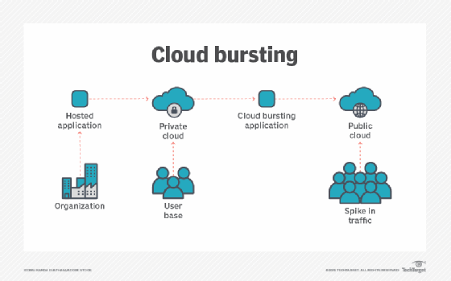

Cloud Bursting is a hybrid cloud strategy where an application runs in a private cloud or data centre and "bursts" into a public cloud during spikes in demand. This approach is important because it provides flexibility and cost-efficiency. Organizations can avoid over-provisioning their private infrastructure for occasional high demand by leveraging the public cloud when needed.

An organization can take one of the following approaches to cloud bursting:

**Distributed load balancing**

**Automated bursting**

**Manual bursting**

Q7.Discuss security architecture in CC

Cloud Computing Security Architecture

Security in cloud computing is a major concern. Proxy and brokerage services should be employed to restrict a client from accessing the shared data directly. Data in the cloud should be stored in encrypted form.

Security Planning

Before deploying a particular resource to the cloud, one should need to analyze several aspects of the resource, such as:

1. A select resource needs to move to the cloud and analyze its sensitivity to risk.
2. Consider cloud service models such as IaaS, PaaS, and These models require the customer to be responsible for Security at different service levels.
3. Consider the cloud type, such as public, private, community, or
4. Understand the cloud service provider's system regarding data storage and its transfer into and out of the cloud.
5. The risk in cloud deployment mainly depends upon the service models and cloud types.

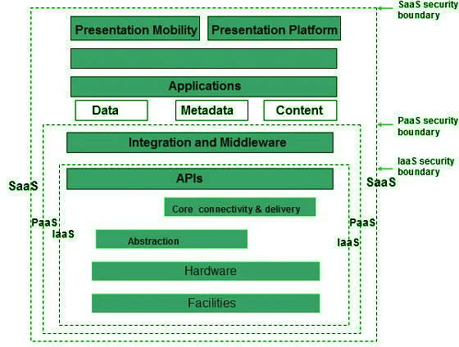

Q8.Attempt any two short notes

a)Xen

Xen is an open source hypervisor based on paravirtualization. It is the most popular application of paravirtualization. Xen has been extended to compatible with full virtualization using hardware-assisted virtualization. It enables high performance to execute guest operating system. This is probably done by removing the performance loss while executing the instructions requiring significant handling and by modifying portion of the guest operating system executed by Xen, with reference to the execution of such instructions.

Pros:

a) Xen server is developed over open-source Xen hypervisor and it uses a combination of hardware-based virtualization and paravirtualization. This tightly coupled collaboration between the operating system and virtualized platform enables the system to develop lighter and flexible hypervisor that delivers their functionalities in an optimized manner.

b) Xen supports balancing of large workload efficiently that capture CPU, Memory, disk input-output and network input-output of data. It offers two modes to handle this workload: Performance enhancement, and For handling data density.

c) It also comes equipped with a special storage feature that we call Citrix storage link. Which allows a system administrator to uses the features of arrays from Giant companies- Hp, Netapp, Dell Equal logic etc.

d) It also supports multiple processor, Iive migration one machine to another, physical server to virtual machine or virtual server to virtual machine conversion tools, centralized multiserver management, real time performance monitoring over window and linux.

Cons:

a) Xen is more reliable over linux rather than on window.

b) Xen relies on 3rd-party component to manage the resources like drivers, storage, backup, recovery & fault tolerance.

c) Xen deployment could be a burden some on your Linux kernel system as time passes.

d) Xen sometimes may cause increase in load on your resources by high input-output rate and and may cause starvation of other Vm’s.

b)Cloud governance

It is the set of policies or principles that act as the guidance for the adoption use, and management of cloud technology services.

It is an ongoing process that must sit on top of existing governance models.

It is a set of rules you create to monitor and amend as necessary in order to control costs, improve efficiency, and eliminate security risks.

Need for Cloud Governance :

By implementing cloud governance, organizations can avoid the following issues as follows.

1. Security and privacy risks :

This issue may arise due to unauthorized downloads/ installation of software, storage of illegal data, and access to restricted sites by users.

2. Vendor lock-in :

Many vendors opt for this, as this clause causes organizations to depend on the cloud service provider (or vendor) for products and services.

3. Cloud Sprawl :

This happens when employees of different departments use different programs and cloud infrastructure from third-party providers without involving the IT department and getting necessary approvals.

4. Shadow IT and unwarranted usage of cloud resources :

This happens when employees in various departments do not follow the rules and regulations as imposed by the IT department on cloud usage resulting in security breaches and fragmented control throughout the organization.

5. Lack of data portability and interoperability :

This happens when the cloud service provider or the inbuilt cloud infrastructure is incapable of connecting well with other software and products outside the organization.

c)Cloud availability

Cloud Availability refers to the ability of a cloud service or infrastructure to remain operational and accessible to users without interruptions. High cloud availability ensures that services, applications, and data hosted in the cloud are accessible to users with minimal downtime or failures. It is typically measured in terms of uptime percentage over a specific period.

3 best practices to achieve high availability in cloud computing

High availability is the crucial test of whether a business can continue to access data and applications when things go wrong in a cloud-based IT infrastructure.

Availability is an important part of service-level agreements in cloud computing to ensure that infrastructure can continue to function even if a component fails. If there is poor availability, a business is unable to access its data or applications -- and potentially loses revenue.

Availability addresses points of failure within systems, databases and applications. High availability, sometimes referred to as HA, better protects companies from disruptions, and it supports productivity and reliability.

Follow these three best practices to achieve high availability in cloud computing.

1. Determine how much uptime you need

2. Understand core high availability components

3. Assess application needs before adding HA

d)Cloud migration

A cloud migration strategy is the high-level plan an organization adopts to move existing on-premises and/or co-located application workloads and their associated data into the cloud. Most plans include a public cloud migration strategy where the target is Amazon Web Services (AWS), Google Cloud Platform (GCP), Microsoft Azure, or other public cloud providers. Although most workloads will benefit from cloud migrations, not all workloads are suitable for migration.

A successful enterprise cloud migration strategy will include prioritizing workloads for migration, determining the correct migration plan for each individual workload, developing a pilot, testing, and adjusting the strategy based on the results of the pilot. A cloud migration strategy document should be created to guide teams through the process and facilitate roll-back if necessary.

Whether or not the source and destination platforms have similar architecture and use of migration tools that are fit-for-purpose will have a significant impact on the effort and cost of migration.

The desired final state is a seamless transition of the applications from on-premises to the desired cloud infrastructure without impacting application availability or day to day operations.